

2006

Trial HSC Examination

CHEMISTRY

Tuesday 29 August 2006, 9am – 12.05pm

General Instructions  - Reading time - 5 minutes  - Working time - 3 hours  - Write using black or blue pen  - Draw diagrams using pencil  - Board approved calculators may be used  - A data sheet and Periodic Table are provided separately  - Write your student number at the top of every page. | Total marks - 100  Section I – 75 marks  Part A (15 marks)  - Attempt Questions 1-15  - Allow about 30 minutes for this part  Part B (60 marks)  - Attempt Questions 16-28  - Allow about 1 hour and 45 minutes for this part.  Section II - 25 marks  Option  - Attempt Question 29  - Allow about 45 minutes for this section

WH
ML
AW
57 students

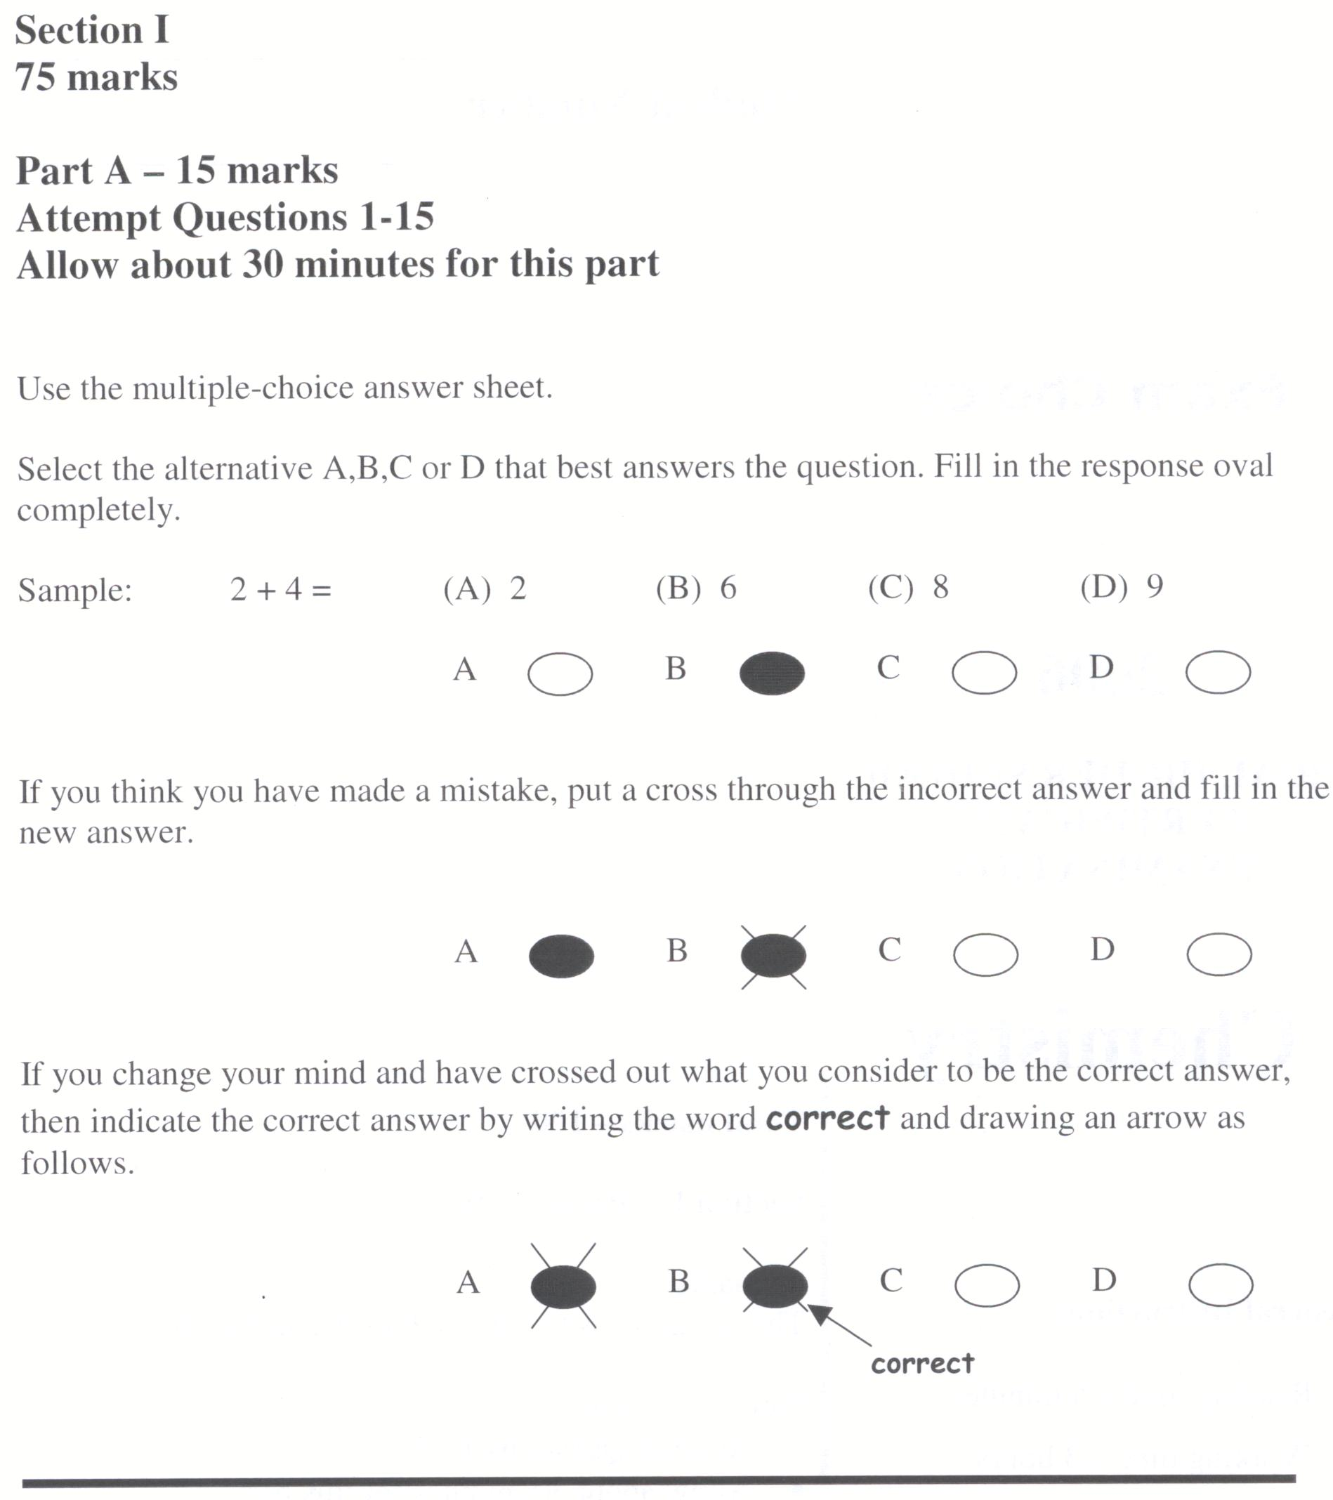

1 | Which of the following is the correct IUPAC name for the molecule below.  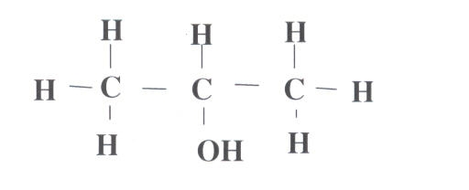  - 1-propanol  - 2-hydroxypropane  - 2-hydroxypropanol  - 2-propanol
2 | What is the oxidation state of chromium in potassium dichromate, K₂Cr₂O₇.  - -2  - +3  - +6  - +8
3 | What is the systematic name for the monomer from which polyvinyl chloride is built?  - chloroethene  - 1,1-dichloroethene  - 1,2-dichloroethene  - vinyl chloride
4 | Which of the following are significant natural sources of sulphur dioxide?  - lightning and bacteria  - bacterial decomposition and volcanoes  - internal combustion engine and air conditioning units  - coal burning power stations and metal ore smelting

5 | Which of the following is the conjugate base of water?  - H₃O⁺  - OH⁻  - H₂O₂  - Cl⁻
6 | Which of the following is the common name for 2-hydroxypropane-1,2,3-tricarboxylic acid?  - acetic acid  - citric acid  - ascorbic acid  - sulphuric acid
7 | Who defined an acid as a substance containing oxygen?  - Lavoisier  - Davy  - Arrhenius  - Lowry and Bronsted
8 | Which of the following equations describes a buffer?  - HCl(aq) + NaOH(aq) → NaCl(aq) + H₂O(l)  - HCl(aq) + H₂O(aq) → Cl⁻ + H₃O⁺  - H₂SO₄(aq) + H₂O(l)  HSO₄⁻(aq) + H₃O⁺ (aq)  - CH₃COOH(aq) + H₂O(l)  CH₃COO⁻(aq) + H₃O⁺ (aq)
9 | What is the pH of a 1.5 × 10⁻⁴molL⁻¹ solution of sulphuric acid assuming complete ionisation?  - 4.0  - 3.8  - 3.5  - 1.5

10 | Which of the following pairs are isomers?  - graphite and diamond  - cyclohexane and 1-hexene  - cyclohexane and cyclohexene  - carbon-12 (¹² C) and carbon-14 (¹⁴C)
11 | Consider the following standard reduction potentials:  Using the above table, which of the following metals is the strongest OXIDANT?  - Ca²⁺  - Pb²⁺  - Cu²⁺  - Ag⁺
  Half-reaction | E°(V)
  Ca²⁺ + 2e⁻  Ca | -2.87
  Pb²⁺ + 2e⁻  Pb | -0.13
  Cu²⁺ + 2e⁻  Cu | +0.34
  Ag⁺ + e⁻  Ag | +1.80
12 | To which area had Atomic Absorption Spectroscopy contributed the most?  - The analysis of organic water pollutants  - The analysis of pollutant gas levels in the atmosphere  - The identification and effects of trace elements  - The identification of metal ions in water

13 | A sample of water was collected downstream from a factory producing batteries.  The sample was analysed for zinc content using the following method.  - Standard solutions of zinc were used to prepare a calibration curve.  - One litre of river water was collected.  - A 100 mL sample of this water was diluted to 1 L using distilled deionised water.  - A 50 mL sample of the dilute solution was used to aspirate into an atomic absorption spectrometer.  The following graph was obtained using standard solutions of zinc nitrate.  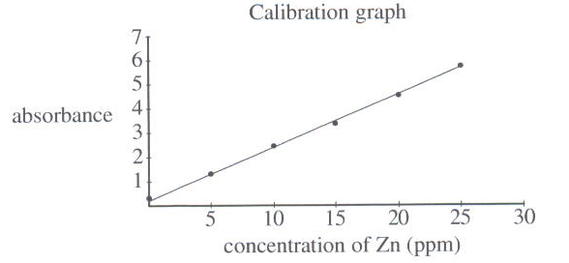  The absorbance reading of the 50 mL sample of the diluted river water was 1. Which of the following is closest to the concentration of zinc in the original river water sample?  - 10 ppm  - 40 ppm  - 50 ppm  - 100 ppm
14 | The table below gives the results of some tests performed on water from four different sites.  Which site is most likely to be down stream from a farm?  - Site Q  - Site R  - Site S  - Site T
  Test | Site Q | Site R | Site S | Site T
  Total dissolved solids (ppm) | 350 | 120 | 50 | 635
  Phosphate (ppm) | 2.2 | 0.02 | 0.01 | 1.1
  Dissolved oxygen (ppm) | 2.5 | 5.0 | 7.0 | 3.5
  Micro-organisms (CFU/100mL) | 190 | 220 | 1 | 2
15 | A student performed an investigation to measure the sulphate content of ammonium sulphate lawn fertiliser by precipitating the sulphate as barium sulphate (BaSO₄) and weighing the precipitate. His results are tabulated below.  What is the percentage of sulphate, by mass, in the measured ammonium sulphate fertiliser?  - 17.1 %  - 24.4 %  - 41.5 %  - 72.7 %
  What was weighed | Mass (g)
  Ammonium sulphate fertiliser sample | 2.00
  Clean filter paper | 1.05
  Filter paper + dry barium sulphate precipitate | 1.88

Section I (continued)

Part B – 60 marks
Attempt Questions 16-28
Allow about 1 hour and 45 minutes for this part.

Answer the questions in the spaces provided.

Show all relevant working in questions involving calculations.

Question 16 (6 marks)  Ethanol can be produced by the addition of water to ethylene OR by fermentation of sugars.  - Give the equation for the production of ethanol by the addition of water to ethylene.  ………………………………………………………………………………................  - Justify the steps for the production of ethanol by fermentation in the school laboratory.  ………………………………………………………………………………................  ………………………………………………………………………………................  ………………………………………………………………………………................  ………………………………………………………………………………................  ………………………………………………………………………………................  ………………………………………………………………………………................  Question 16 continues over the page | Marks  1  2
- Discuss the potential wide-scale use of ethanol as an alternative fuel to petrol in cars.  ………………………………………………………………………………................  ………………………………………………………………………………................  ………………………………………………………………………………................  ………………………………………………………………………………................  ………………………………………………………………………………................  ………………………………………………………………………………................  ………………………………………………………………………………................  ………………………………………………………………………………................  ………………………………………………………………………………................  ………………………………………………………………………………................  ………………………………………………………………………………................  ………………………………………………………………………………................  ………………………………………………………………………………................  ………………………………………………………………………………................  ………………………………………………………………………………................  ………………………………………………………………………………................  ………………………………………………………………………………................ | Marks  3
Question 17 (8 marks)  A student assembled the following equipment in order to determine the Molar Heat of Combustion of ethanol.  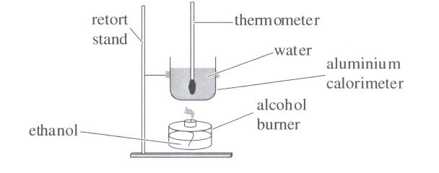  Experimental results found that the temperature of 100 mL of water increased from 18°C to 58°C on burning 0.76g of ethanol.  - Define the term molar heat of combustion.  ………………………………………………………………………………................  ………………………………………………………………………………................  ………………………………………………………………………………................  - Write a balanced chemical equation to show the complete combustion of ethanol.  ………………………………………………………………………………................  - Calculate the Molar Heat of Combustion of ethanol based on the experimental results.  ………………………………………………………………………………................  ………………………………………………………………………………................  ………………………………………………………………………………................  ………………………………………………………………………………................  ………………………………………………………………………………................  ………………………………………………………………………………................  - Explain how this calculated value would compare to the theoretical value.  ………………………………………………………………………………................  ………………………………………………………………………………................  ………………………………………………………………………………................  ………………………………………………………………………………................  (e) Identify a potential hazard in this experiment and outline how you addressed this  hazard  ………………………………………………………………………………................  ………………………………………………………………………………................  ………………………………………………………………………………................  ………………………………………………………………………………................ | Marks  1  1  2  Marks  2  2
Question 18 (4 marks)  A Galvanic cell may be constructed by placing one half-cell in a porous pot inside another half-cell as shown below.  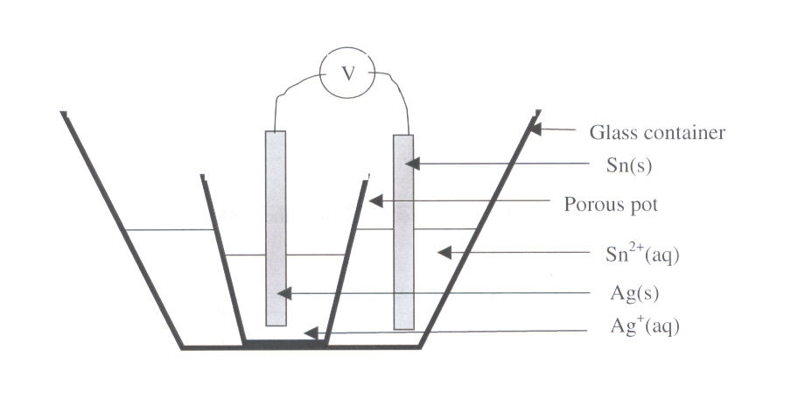  - Identify the cathode.  ………………………………………………………………………………….............  - Calculate the theoretical voltage of this cell.  …………………………………………………………………………………............  …………………………………………………………………………………............  …………………………………………………………………………………............  - Explain the function of the porous pot.  …………………………………………………………………………………............  …………………………………………………………………………………............  …………………………………………………………………………………............  …………………………………………………………………………………............ | Marks  1  1  2

Question 19 (3 marks)  You performed a first-hand investigation to identify the pH of salt solutions. If solutions of ammonium chloride and sodium chloride were used, predict the acidic, basic or neutral nature of those salts.  ………………………………………………………………………………................  ………………………………………………………………………………................  ………………………………………………………………………………................  ………………………………………………………………………………................  ………………………………………………………………………………................  ………………………………………………………………………………................  ………………………………………………………………………………................  ………………………………………………………………………………................  ………………………………………………………………………………................  ………………………………………………………………………………................  ………………………………………………………………………………................  ………………………………………………………………………………................  ………………………………………………………………………………................  ………………………………………………………………………………................ | Marks  3
Question 20 (4 marks)  During this course you studied the use of catalysts in a number of different reactions and processes.  - Identify one chemical reaction that uses a catalyst.  ………………………………………………………………………………................  - Name the catalyst used.  ………………………………………………………………………………................  - Explain why the catalyst is used.  ………………………………………………………………………………................  ………………………………………………………………………………................  ………………………………………………………………………………................  ………………………………………………………………………………................  ………………………………………………………………………………................  ………………………………………………………………………………................ | Marks  1  1  2

Question 21 (7 marks)  Copper carbonate is decomposed to carbon dioxide and copper (II) oxide when heated.  The volume of carbon dioxide produced can be measured by displacing water.  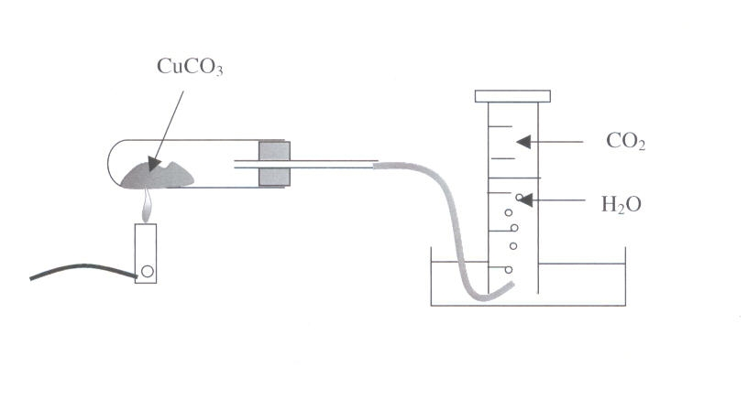  copper (II) carbonate  The results of an investigation into the decomposition of copper (II) carbonate are tabulated below.  - Write the equation for the decomposition of copper (II) carbonate.  ………………………………………………………………………………................ | Marks  1
  Time (s) | Gas Volume at 25°C and 100 kPa (mL)
  10 | 20
  30 | 66
  50 | 84
  70 | 90
  100 | 92
  130 | 92

- Graph the results from this experiment.    - Calculate the mass of copper (II) oxide produced.  ………………………………………………………………………………................  ………………………………………………………………………………................  ………………………………………………………………………………...............  ………………………………………………………………………………...............  - Analyse the accuracy of the procedure for collecting the gas.  ………………………………………………………………………………................  ………………………………………………………………………………................  ………………………………………………………………………………................  ………………………………………………………………………………................  ………………………………………………………………………………................ | Marks  3  2  1

Question 22 (4 marks)    Safety glasses should always be worn during practical experiments involving acids since spills and splashes can occur. The corrosive nature of acids can damage workbenches or pose a risk to people working in the laboratory.  A handbook for risk assessment states:  “To minimise risk, large acid spills should be neutralised with limestone before mopping up.”  Assess this recommended method.  ………………………………………………………………………………................  ………………………………………………………………………………................  ………………………………………………………………………………................  ………………………………………………………………………………................  ………………………………………………………………………………................  ………………………………………………………………………………................  ………………………………………………………………………………................  ………………………………………………………………………………................  ………………………………………………………………………………................  ………………………………………………………………………………................  ………………………………………………………………………………................ | Marks  4

Question 23 (3 marks)  Special techniques are used to ensure accuracy when preparing a standard solution and conducting a titration.  Describe ONE such technique for the preparation of the standard solution AND ONE such technique for conducting the titration.  Explain how each assists in obtaining a valid result.  ………………………………………………………………………………................  ………………………………………………………………………………................  ………………………………………………………………………………................  ………………………………………………………………………………................  ………………………………………………………………………………................  ………………………………………………………………………………................  ………………………………………………………………………………................  ………………………………………………………………………………................  ………………………………………………………………………………................  ………………………………………………………………………………................  ………………………………………………………………………………................  ………………………………………………………………………………................ | Marks  3

Question 24 (4 marks)  Explain the importance of monitoring the reaction vessel used in the Haber Process.  ………………………………………………………………………………................  ………………………………………………………………………………................  ………………………………………………………………………………................  ………………………………………………………………………………................  ………………………………………………………………………………................  ………………………………………………………………………………................  ………………………………………………………………………………................  ………………………………………………………………………………................  ………………………………………………………………………………................  ………………………………………………………………………………................  ………………………………………………………………………………................  ………………………………………………………………………………................  ………………………………………………………………………………................  ………………………………………………………………………………................  ………………………………………………………………………………................  ………………………………………………………………………………................  ………………………………………………………………………………................  ………………………………………………………………………………................ | Marks  4

Question 25 (4 marks)  Ions produced by industry and farming van move into the environment where they can cause problems.  Describe and explain evidence for the need to monitor levels of ONE named ion used by society.  ………………………………………………………………………………................  ………………………………………………………………………………................  ………………………………………………………………………………................  ………………………………………………………………………………................  ………………………………………………………………………………................  ………………………………………………………………………………................  ………………………………………………………………………………................  ………………………………………………………………………………................  ………………………………………………………………………………................  ………………………………………………………………………………................  ………………………………………………………………………………................  ………………………………………………………………………………................  ………………………………………………………………………………................  ………………………………………………………………………………................  ………………………………………………………………………………................ | Marks  4

Question 26 (3 marks)  - Define a coordinate covalent bond.  ………………………………………………………………………………................  ………………………………………………………………………………................  - Draw a Lewis electron dot structure to model the formation of the coordinate covalent bond. | Marks  1  2

Question 27 (6 marks)  Ozone is being gradually removed from the stratosphere by our use of chlorofluorocarbons (CFC).  - Identify ONE CFC molecule that has caused problems and its source.  ………………………………………………………………………………................  - Give equations to demonstrate the removal of ozone from the stratosphere by this CFC.  ………………………………………………………………………………................  ………………………………………………………………………………................  ………………………………………………………………………………................  - Evaluate the effectiveness of replacement chemicals for CFC’s.  ………………………………………………………………………………................  ………………………………………………………………………………................  ………………………………………………………………………………................  ………………………………………………………………………………................  ………………………………………………………………………………................  ………………………………………………………………………………................  ………………………………………………………………………………................  ………………………………………………………………………………................  ………………………………………………………………………………................  ………………………………………………………………………………................  ………………………………………………………………………………................  ………………………………………………………………………………................ | Marks  1  2  3

Question 28 (4 marks)  Assess the effectiveness of methods used to purify and sanitise mass water supplies.  ………………………………………………………………………………................  ………………………………………………………………………………................  ………………………………………………………………………………................  ………………………………………………………………………………................  ………………………………………………………………………………................  ………………………………………………………………………………................  ………………………………………………………………………………................  ………………………………………………………………………………................  ………………………………………………………………………………................  ………………………………………………………………………………................  ………………………………………………………………………………................  ………………………………………………………………………………................  ………………………………………………………………………………................  ………………………………………………………………………………................ | Marks  4

Question 29 – Shipwrecks, Conversation and Corrosion (25 marks)
Marks

3

1

1

1

2

4

- In 1780 Luigi Galvani generated an electric current by taking two wires made of different metals, at one end joining them together and at the other end placing them on a dissected frog’s leg muscle.

The muscle contracted, prompting Galvani to coin the term animal electricity.

Outline how a more recent chemist, Alessandro Volta, interpreted Galvani’s results and describe how he built on Galvani’s work.

- The experiment below was set up to investigate the factors that affect the rate of electrolysis.

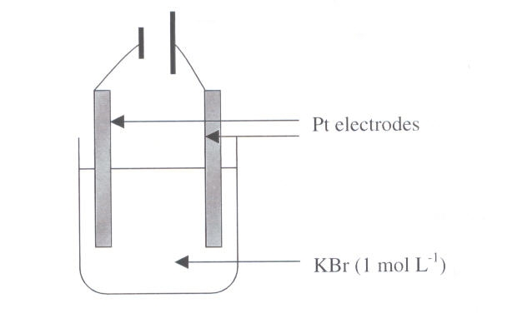
- Give the half-equation for the reaction occurring at the cathode.

- Calculate the voltage required for the reaction to proceed.

- In some investigations, reaction rate can be measured by recording the change in temperature.

Describe what the investigator could have recorded as a measure of reaction rate in this investigation.

- Identify one other factor that the investigator may have varied and give the likely result of varying this factor on reaction rate.

- Describe how the process of cathodic protection minimises rusting of iron in marine environments.

Question 29 continues

(d) In the year 1770 Captain Cook tossed 10 cannons overboard when his
ship, the Endeavour, hit a coral reef.

Marks

1

1

3

2

6

These were discovered 200 years later but they were in poor condition. They were covered in coral (CaCO₃) and extensively pitted and corroded.

They were recovered and firstly kept in a basic sodium hydroxide solution.

- Explain why the cannons would be kept in a basic solution before work began on them.

- Describe how the coral may have been removed.

- Describe and explain how the corrosion may have been halted and reversed.

- Describe and explain how the cannons may be treated to protect them from further corrosion as they are displayed.

- Identify and discuss factors that influence the rate of corrosion of a steel shipwreck in deep ocean waters.

END OF PAPER

BLANK PAGE

